2.01 – Metric System Worksheet Name:______________________________
- Click here (http://www.funbrain.com/cgi-bin/meas.cgi?A1=s&A2=1&A3=2) to practice reading a metric ruler.

- How many did you answer correctly out of 10? ________

- 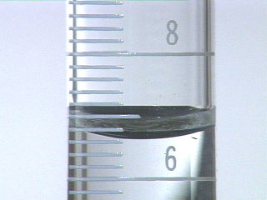What measurement do you read on this graduated cylinder? _________ (Circle one:) milliliters or millimeters

Click here ( ) and answer the questions below:
reading a triple beam balance

- 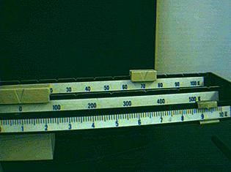What is the measurement on this triple beam balance? __________

- What is the unit used in Question #4? ____________

